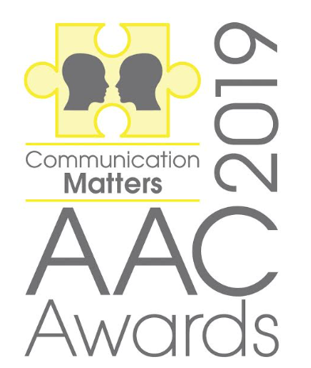 |  | Your name:  Relation to nominee / job title:  Organisation:  Contact email address:  Contact phone number:  Are you likely to be attending the awards on 11th October 2019? YES / NO  Name of nominee:  Please include a photo (if you have gained their permission to do so)  Organisation / position held:  Is the nominee likely to be attending the awards on 11th October 2019? YES / NO  Who should we contact if the person is shortlisted?  Please attach any evidence including a statement of between 200 – 250 words on why this person / organisation should be nominated. The most successful nominations could include video or photo evidence of the nominee’s work / skills or an online link. Any additional brief testimonials from a range of people working with this person / team are also encouraged.  Only the information you have provided will be used by the panel when reaching their decision, so the more information you provide the better.  Please email this form and any attachments to: admin@communicationmatters.org.uk  OR send by post to: Communication Matters, 3rd floor, University House, University of Leeds, Leeds, LS2 9JT or for more information please ring: 0113 343 1533  www.communicationmatters.org.uk  ISAAC (UK) | UK Chapter of the International Society for Augmentative and Alternative Communication  Registered Office: ISAAC (UK), Garbutt & Elliott, Arabesque House, Monks Cross Drive, York YO32 9GW  Registered in England & Wales No. 01965474 | Registered Charity No. 327500

PLEASE TICK THE AWARD THAT YOU ARE NOMINATING FOR:

Jamie Munro award

Alan martin award

AAC INNOVATION AWARD

RISING STAR AWARD

SETTING OF THE YEAR AWARD

RESEARCH AWARD

STUDENT AWARD

COMMUNITY INCLUSION AWARD

nOMINATION FORM

Terms & Conditions:

- Closing date for nominations: Friday 2nd August. *NOW EXTENDED TO FRIDAY 30TH AUGUST*
- Short-listed nominees will be informed by: Friday 6th September.
- Winners will be notified by: Friday 20th September.
- The winner will be announced at the Awards ceremony on 11th October.
- If you would like to attend the Awards, please register your place online by: 25th September.

Privacy Notice:
- Under the General Data Protection Regulation (EU) 2016/679 ("GDPR"), we require you to confirm that you have permission to share the personal data required for making a submission to the AAC Awards. This includes gaining permission from the nominee to share their details. The data will be accessed by Communication Matters personnel and the judging panel. This form and any evidence sent with it will be disposed of immediately following the awards, in line with our Privacy Policy. Please tick this box to show you agree

