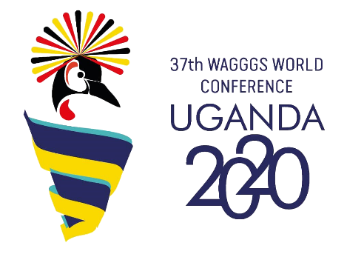**ORGANISATION OF 38th WAGGGS**

**WORLD CONFERENCE**

**Bidding process**

**Expression of interest form:**

Please complete this Expression of Interest form as fully as possible and return by **14 February 2020**. If you need any assistance, please contact Aina Fontanella, Events Manager, on +44 (0) 7825107893 or woco@wagggs.org.

Name of Member Organisation (MO):

Main MO contact for bidding process:

Phone:

Email:

1. **MEMBER ORGANISATION QUESTIONS**
   1. Why do you want to host the Conference? How will your MO benefit from hosting the Conference?
   2. Describe the experience and expertise your MO has with hosting international events (camps, conferences, trainings). These can be WAGGGS or other partner organisation events.
   3. Describe the human resources capacity of your MO to host the Conference (number of staff and volunteers who would be involved in planning, ability to hire extra staff to support the planning).
   4. Describe the financial situation of the MO which confirms you have the capacity to plan and host the Conference (your accounting and financial reporting systems and controls, the skill of your staff and/or volunteers in budget management). Please also include your fundraising ability.
   5. If you have completed the Capacity Building Assessment in the last year[1], please provide the results from the assessment on the level of your MO (At Risk, Foundational, Moderate, Robust) for the following:

* Strategy and Planning
* Governance
* Adult leadership practice
* Organisational Management
* Finance
* Resource Mobilisation
* Image & Visibility
* Influence
* Recruitment & Retention

1. **GENERAL COUNTRY QUESTIONS**
   1. Will you need to obtain any governmental or other permissions to hold the Conference in your country. If so, do you foresee any difficulties obtaining them?
   2. Describe the level of support you are expecting from your national and/or local government with hosting the Conference.
   3. Describe the level of support you are expecting from national and/or local tourism body (e.g. Ministry of Tourism, Convention Bureau) with hosting the Conference. This can be monetary or in kind support, or in form of advice and networking.
   4. It is imperative for all Conference participants to feel safe before, during and after the event. Provide information on the security situation in your country including any travel warnings that are in place. Please advise of any major political events (e.g. elections) or other events (e.g. sporting) that would be taking place in the year of the Conference.
   5. Describe the process of obtaining visa for participants from MOs, including information on any difficulties that might occur.

Signature:

Date:

1. If you have not completed the Capacity Building Assessment in the last year, please speak to your Relationship manager to guide you through the process before you submit the Expression of interest.